

University of Engineering & Technology Mardan
Department of Computer Software Engineering

Submitted By | Umar Hayat
Semester | 6th Spring 2026
Registration No | 23MDSWE274
Batch | 06
Subject | HCI Lab Task # 01
Submitted To | Dr. Hamidullah

1. Objective
The objective of this lab is to identify UX goals using the UX Honeycomb model and relate specific interface elements to these goals with practical evidence gathered during a live task.

2. Methodology
2.1 Design Framework
The UX Honeycomb, developed by Peter Morville, is a framework used to evaluate product quality across seven dimensions: Useful, Usable, Findable, Accessible, Desirable, Credible, and Valuable.
2.2 System Selection
- Application Name: Goto
- Platform: Web
- Target Users: Consumers (Men, Women, Kids)
- Primary Purpose: Browsing and purchasing fashion, electronics, and lifestyle products.

Observation: While the search and product selection were successful, clicking the "Add to Cart" button resulted in no system response. The item did not appear in the cart, preventing the completion of the purchase flow.

3. Analysis and Results
The following table evaluates the site based on the observed behavior during the failed "Add to Cart" task (www.goto.com.pk).
Table 1: User Experience Goals and Interface Analysis (www.goto.com.pk)
UX Facet | Observed Design Element | Screenshot Ref | Strength/Weakness | Suggestion for Improvement
Useful | Wide product range (Fashion, Grocery) | Fig 1 | Strength: Fulfills the primary need for a variety of goods. | Ensure high utility by keeping stock levels updated in real-time.
Usable | "Add to Cart" Button | Fig 2 | Weakness: Critical failure; the button is non-functional. | Fix the button logic to ensure it triggers the "Add to Cart" event.
Findable | Search bar and Categories | Fig 3 | Strength: Navigation structure is familiar and easy to find.
Accessible | UI Contrast and Layout | Fig 4 | Strength: Good color contrast for readability. | Weakness: Text size for descriptions is too small for some users.
Desirable | Promotional Visuals | Fig 5 | Strength: High-quality imagery enhances aesthetic appeal. | Use more video content to better showcase product features.
Credible | Security Badges and HTTPS | Fig 6 | Weakness: Technical bugs (broken buttons) damage user trust. | Add immediate visual feedback (success/error messages) for all actions.
Valuable | Marketplace Discounts | Fig 7 | Weakness: Potential value is lost if the user cannot purchase. | Optimize the checkout flow to ensure the business can capture sales.

4. Discussion and Reflection
4.1 Strongest Facet: Useful
The site is conceptually Useful because it provides a centralized platform for various consumer needs, ranging from groceries to fashion.
4.2 Weakest Facet: Usable
The weakest facet is Usable. The failure of the "Add to Cart" button is a severe usability blocker. In HCI, this represents a major "Gap of Execution"—the user knows what they want to do, but the interface does not provide the expected result, leading to frustration.
4.3 Conclusion
The inability to add items to the cart makes the site effectively unusable for e-commerce. To enhance the overall experience, the developers must fix this technical glitch and provide clear feedback signals. These changes would restore Credibility and ensure the site remains Valuable to both the user and the business.

5. Appendix: Required Screenshots
- Fig 1: 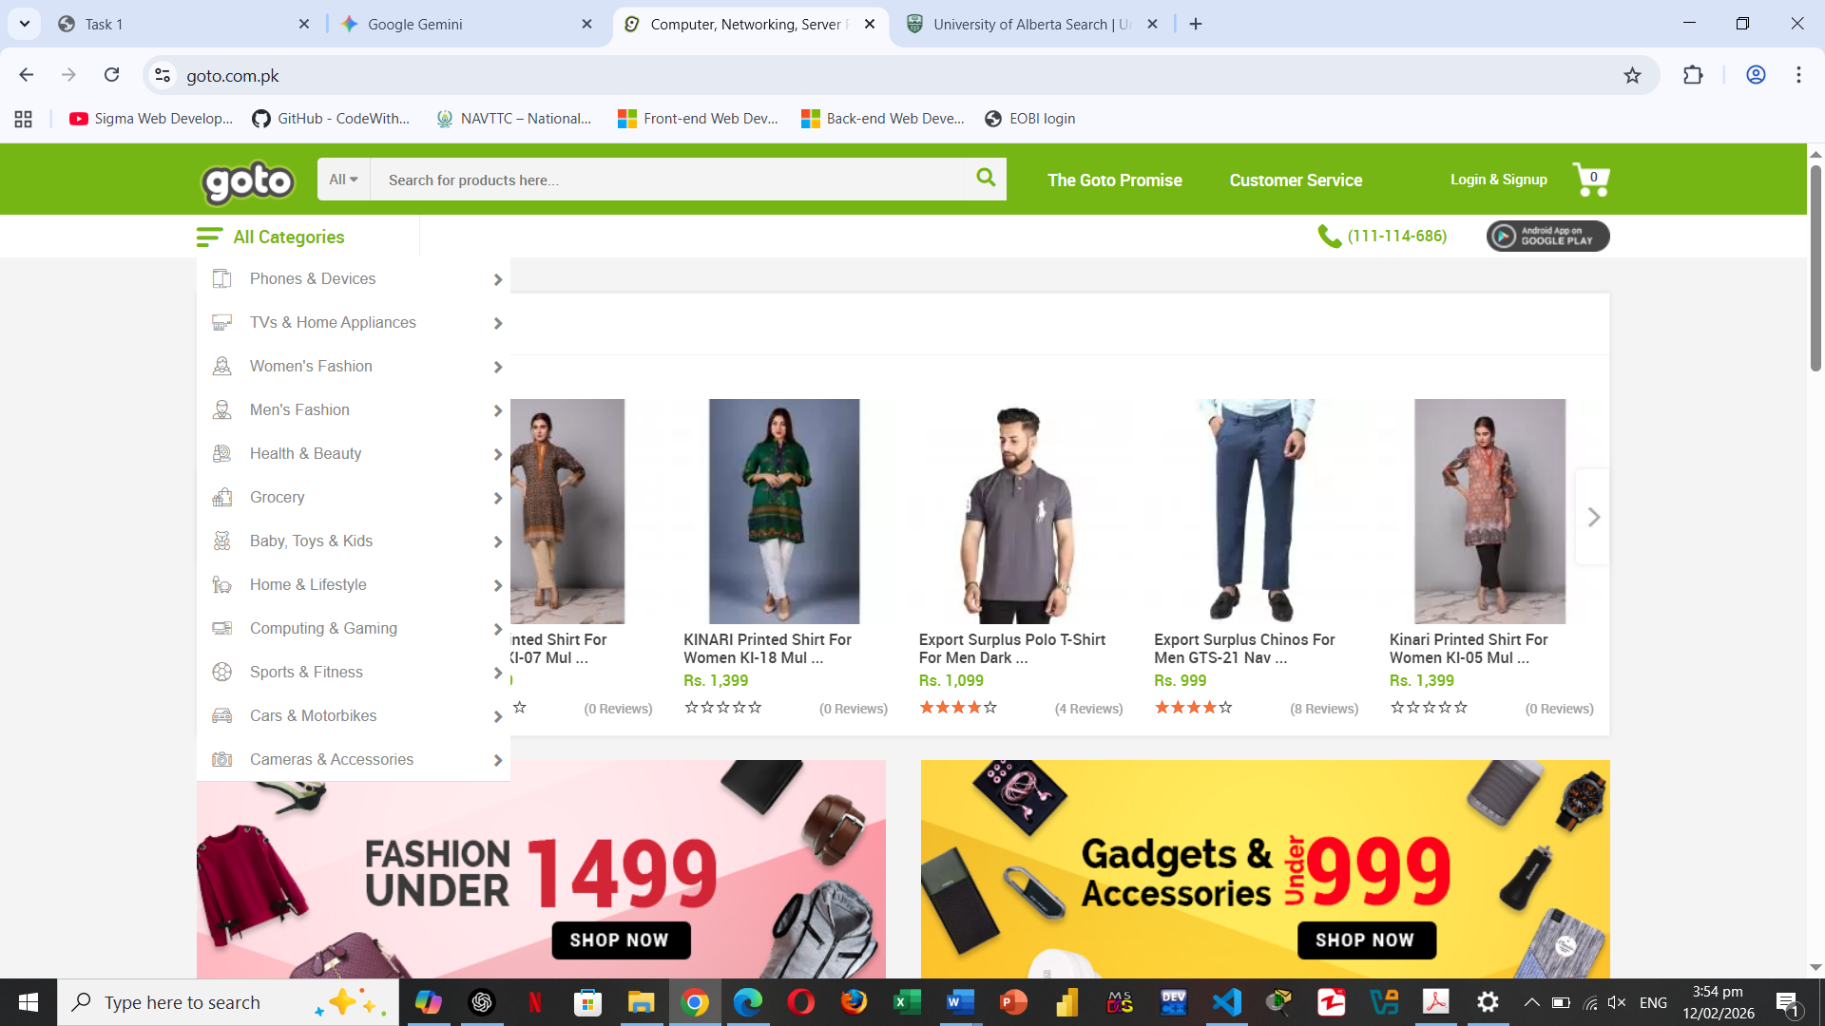

- Fig 2:
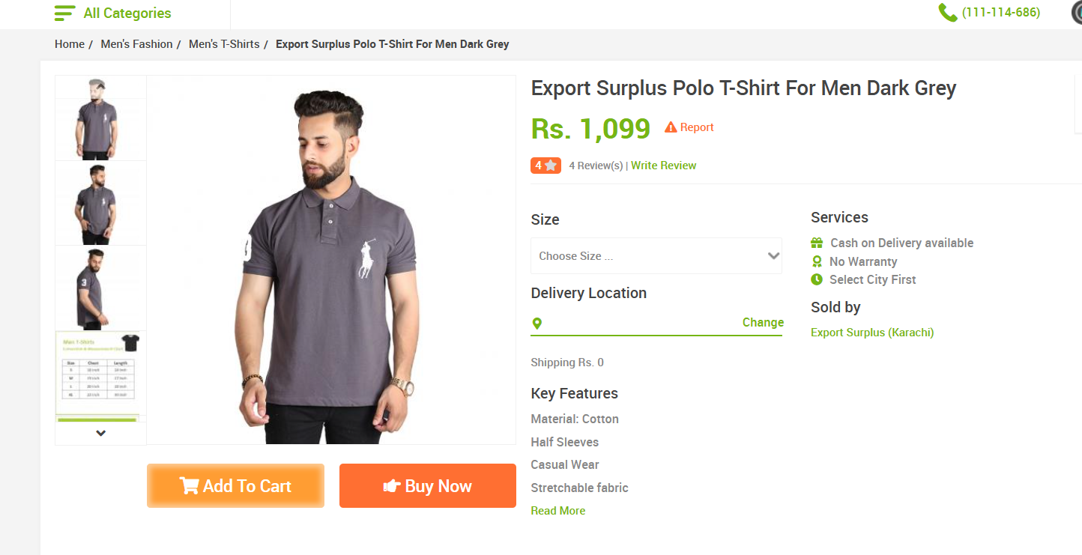

- Fig 3:
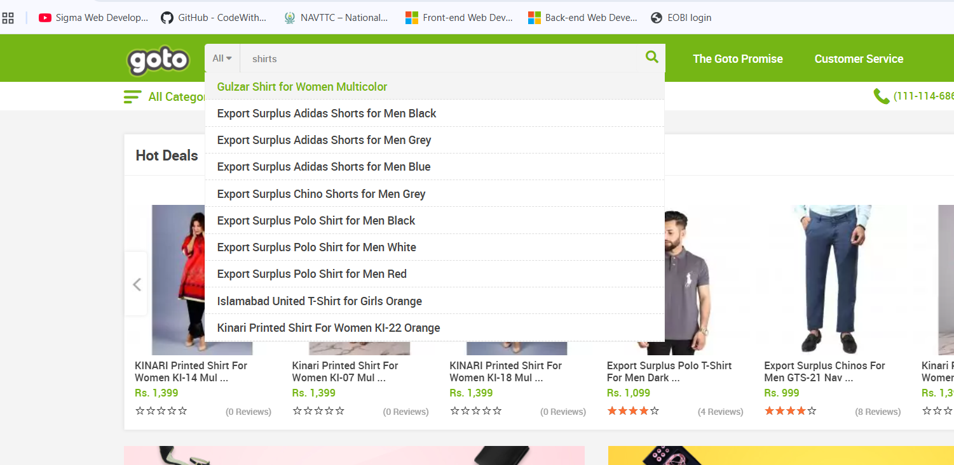

- Fig 4:
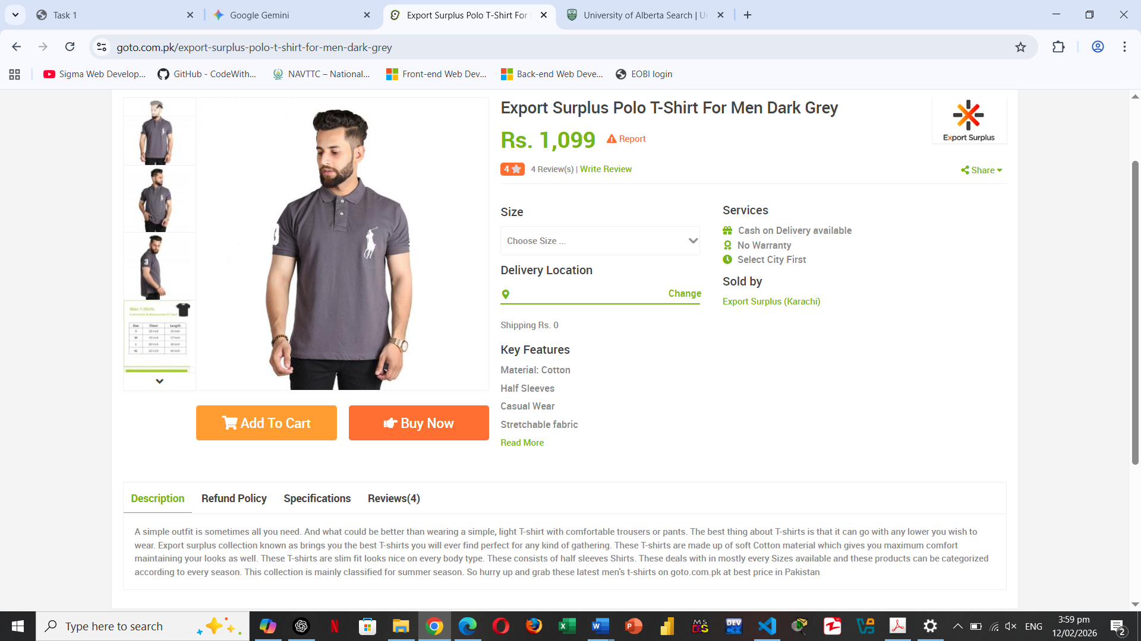

- Fig 5:
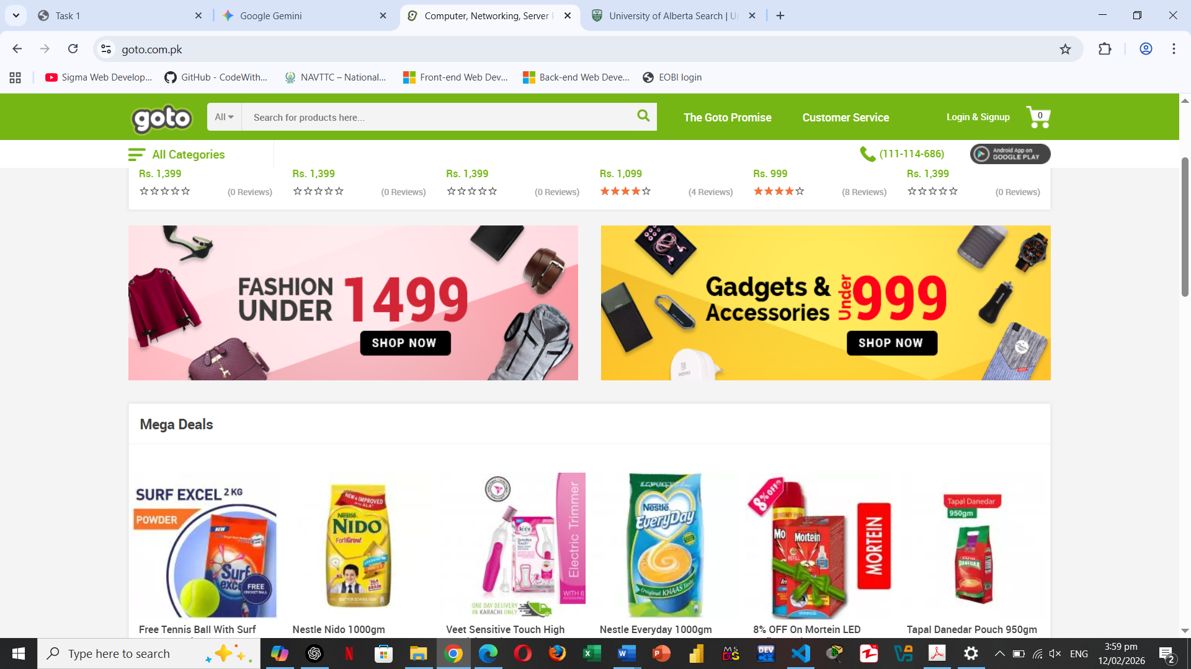

- Fig 6:
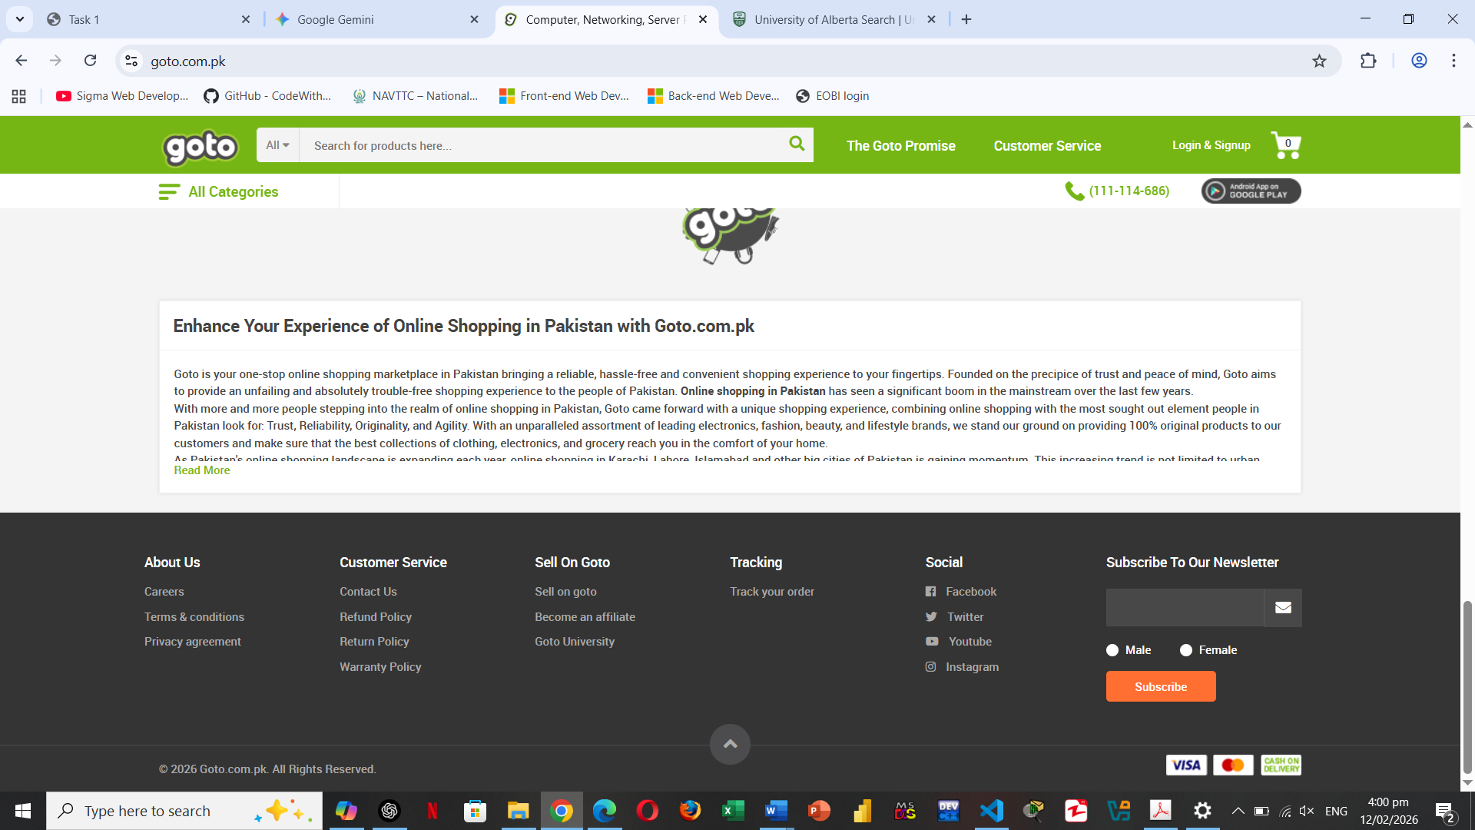

- Fig 7:
